Date: 26-Jul-2020

The Supervisor,

Mr. Mijanur Rahman

Assistant professor

Department of CSE (BUBT)

Sub: Permission to submission the project proposal.

Dear Sir,

We are pleased to enclose here our proposal on Inventory Management Solution: German Dairy. We hope this proposal will allow you to come to a decision regarding support for this project in the coming weeks.

We all are really interested to create this basic software at this moment with the help of you and wants to improve more and more feature in this software in future.

We will be happy to respond to any questions you may have about the proposal.

We thank you again for your consideration and look forward to hearing from you soon.

Regards,

S M Masfequier Rahman Swapno

Dept. of CSE, BUBT

**Bangladesh University of Business & Technology (BUBT)**

Department of Computer Science and Engineering

**A Project Proposal**

**On**

**Inventory Management Solution: German Dairy**

**Group Members**

**ID: Name:**

18192103087 S M Masfequier Rahman Swapno

Submission Date: 26.07.2020

**Table of Content**

|  |  |  |
| --- | --- | --- |
| **Serial No:** | **Title** | **Page No:** |
| 1  2 | Abstract  Introduction | **4**  **5** |
| 3 | Problem Statement | **6** |
| 4 | Goals/Objective | **6** |
| 5 | Existing System Analysis | **7** |
| 6 | Features/Scopes of proposed project | **8** |
| 7 | Development Model | **9** |
| 8 | Solution Overview | **10** |
| 9 | Requirements | **13** |
| 10 | Activity and Time Schedule | **13** |
| 11 | Development Team & Stakeholders | **14** |
| 12 | System  Analysts Recommendation | **14** |
| 13 | References | **14** |

**ABSTRACT**

The GERMAN DAIRY Management System deals with all kinds of Accountant, Store details, Selling Item information details. German Dairy management system tracks all the details of any branch from the 1st day to the end of expected time which can be used for all reporting purpose, progress in every month and all this will be available for future reference too.

**Introduction**

This project is a software based selling system for a Chocolate shop. The project objective is to deliver the online/offline shopping application into a super shop. It is a form of electronic commerce. This project is an attempt to provide the advantages of online billing to shop manager of a real shop. It helps selling the products in the shop anywhere through server by using this database from any branch.

A shop generally run by a person or a group of stuffs and all transaction, payment & information write down or maintain in manually. Could you imagine a shop run in fully automated and all types of payment, billing, transaction history maintain by a computer which accuracy almost 100%. We create a software solution for this type of shop management.

**Problem Statement:**

**Problem-** A shop generally run by a person or a group of stuffs and all transaction, payment & information write down or maintain in manually. This is costlier because need to use more hardware like paper, pen and calculator. The main problem is in manual system it should be checked again for confirmation.

**Solution-** Could you imagine a shop run in fully automated and all types of payment, billing, transaction history maintain by a computer which accuracy almost 100%. That’s why we save more equipment cost for our shop and that is more benefit for us also in this system doesn’t need another confirmation check. We create a software solution for this type of shop management.

**Objective:**

1. **Planned approach towards working: -**This is a planned by us to digitally run a shop. The working in the organization will be well planned and organized. The data will be stored properly in data stores, which will help in retrieval of information as well as its storage.

2. **Accuracy: -** Computer is the one of the most accuracy product in this moment and manage something by using computer is easier. The level of accuracy in the proposed system will be higher. All operation would be done correctly and it ensures that whatever information is coming from the center is accurate.

3. **Reliability: -** The reliability of the proposed system will be high due to the above stated reasons. The reason for the increased reliability of the system is that now there would be proper storage of information.

4. **No Redundancy: -** In the proposed system utmost care would be that no information is repeated anywhere, in storage or otherwise. This would assure economic use of storage space and consistency in the data stored.

5. **Immediate retrieval of information: -** The main objective of proposed system is to sell specific product on time, stock product, and maintain all details of all brunch of the shop.

6. **Immediate storage of information: -** In manual system there are many problems to store the largest amount of information.

7. **Easy to Operate: -** The system should be easy to operate and should be such that it can be developed within a short period of time and fit in the limited budget of the user.

**Existing SystemAnalysis:**

1. Inventory Management System (BdTask LTD.)

**About:** By use this software a Shop can be automation and all types of account invoice, employee, stock, products managed by the software. This software is managed by admin and operate by admin & salesman. The primary stage of this software is connect to online because it’s an online based software & one can access it from anywhere with his admin id.

**Feature:**

a. Sales any products instantly

b. Find any products details instantly

c. Add any products to the system instantly

d. Instant report finding

e. POS Invoice System

**Limitation:**

a. If Internet connection fall, then the system will be breakdown.

b. This software has not barcode reading & generate system

c. This software has not products return system

d. This software was not used in offline.

2. Inventory Management System (tradegecko)

**About**: Inventory management is a systematic approach to sourcing, storing, and selling inventory—both raw materials (components) and finished goods (products).

In business terms, inventory management means the right stock, at the right levels, in the right place, at the right time, and at the right cost as well as price.

**Feature:**

a. Reduce costs

b. Optimize fulfillment

c. Provide better customer service

d. Prevent loss from theft, spoilage, and returns

**Limitation:**

a. If Internet connection fall, then the system will be breakdown.

b. This software has not barcode reading & generate system

c. This software has not products return system

d. This software was not used in offline.

**Scope of the Project:**

1. Information about all brunch and brunch admin details. That can be easy to contact any brunch admin for any types of problem.
2. Shopping bill generate automatically that’s why there is no chance to wrong calculation.
3. All product are included in our database that’s why we can see easily any products stock remaining and all details about product.
4. All selling details store in our main database so we can easily see any types of information on any date from our database.

That’s all works done by manually needs more cost but now it can be more cost friendly for everyone.

# DevelopmentModel:

WearechoosingSystemDevelopmentLifeCycleApproach(SDLC)fordevelopingour project. Because, It’s the most commonly used and most rigid system development approach.

The formal SDLC is a sequential process which begins with identifying the system objectives (needs of end users) and goes through various stages,including:

* + System analysis (technical components required)
  + System design(architecture)
  + Coding(programming)
  + Testing (errors and bugfixing)
  + Implementation (execution in theorganization)
  + Use (end users employingDSS)
  + Evaluation (verification of functions andcapabilities)
  + Modification (adjustmentrequired)

# Solution Overview:

Here we’ve created single and effective solution for our project. Below is the DFD, Use Case Diagramand ERD of our solutions:

**DFD:**

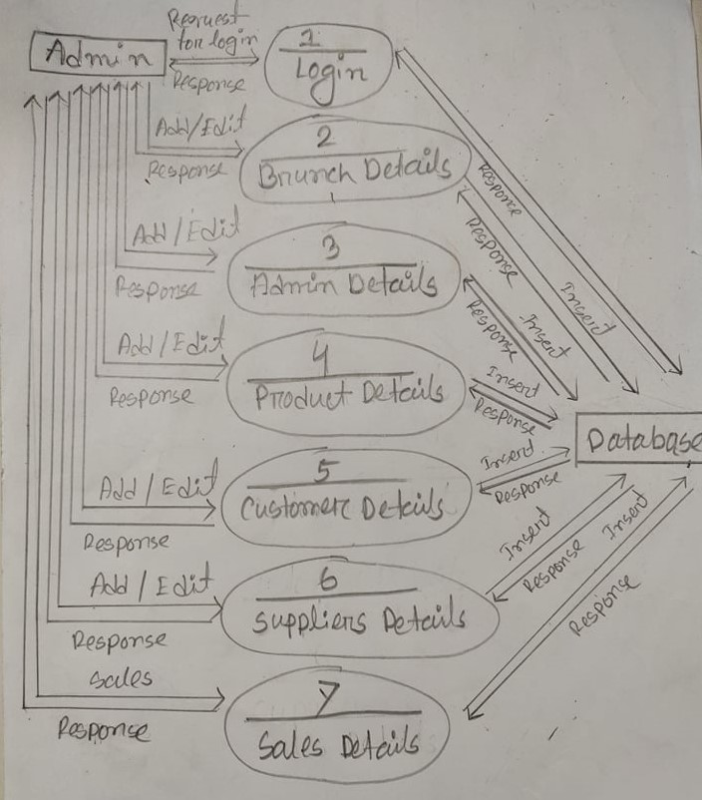

**Use Case Diagram:**

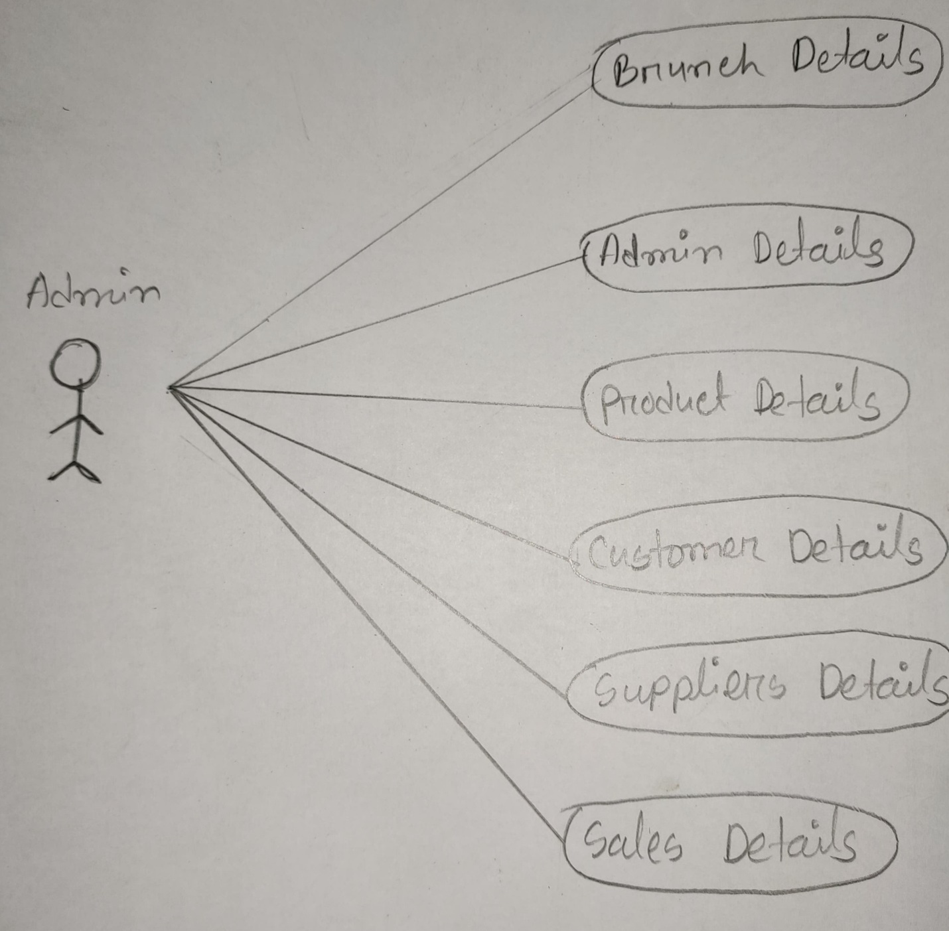

**ERD:**

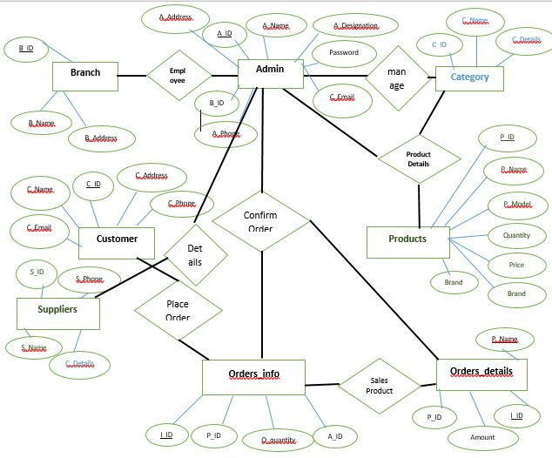

**Requirements:**

**Pc Requirement:**

1. Operating System(Any)
2. Software: Visual Studio, XAMPP, MySQL, MySQL connector, Web browser (Any)
3. Hard Disk: 120GB (minimum)
4. RAM: 4GB (minimum)
5. Processor: Duel-core orabove

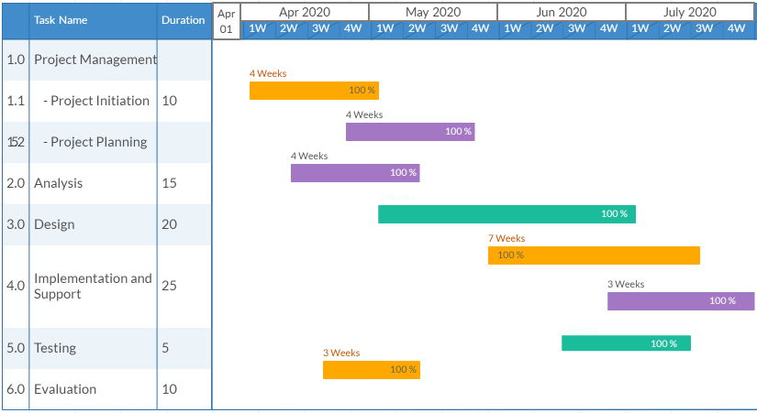**Activity and TimeSchedule:**

**Development Team &Stakeholders:**

|  |  |  |  |
| --- | --- | --- | --- |
| **ID** | **Name** | **Designation** | **Responsibilities** |
| 17182103147 | Md. Imriaz Uddin | Team Leader& Programmer | Team managing, Co-coordinating among members and organize the project works to achieve the goals code for the software. |
| 17182103154 | Umma Sumaiya Siddika | Designer& Assistant programmer | Design the layout and backend design. |
| 17182103155 | **Syed Sanaul Haque** | DBA | Database Design and Administrator |
| 17182103156 | **Marjana Sariat Mahir** | Assistant DBA | Assistant Database Design and Administrator |
| 17182103158 | **Syma Nusrat Ananya** | Designer | Design and analyses the system |

**System Analysts Recommendation:**

We have made single solution models for project. We assumed that this solution model will best fit for our project. Because, it is more secure, reliableand user specific.We compare more than five existing models and decided this is the best process.

**References**

[1]. Bdtask.com. (2020). *Inventory Management System | best inventory control system*. [online] Available at: https://www.bdtask.com/inventory-management-system.php [Accessed 23 Feb. 2020].

[2].Tradegecko.com. (2020). *What is Inventory Management? 10 guides to mastering commerce*. [online] Available at: https://www.tradegecko.com/inventory-management [Accessed 23 Feb. 2020].

[3].Assignment Point. (2020). *Super Shop Management System Sales - Assignment Point*. [online] Available at: https://www.assignmentpoint.com/business/management/super-shop-management-system-sales.html [Accessed 24 Feb. 2020].

[4].From youtube tutorial https://www.youtube.com/watch?v=C9s0H6yeFLQ